**用Flask-Migrate進行資料庫遷移**

<https://stackoverflow.com/questions/32311366/alembic-util-command-error-cant-find-identifier>

flask db init

flask db migrate -m "initial migration"

flask db upgrade

|  |
| --- |
| * 當以上步驟皆做過，但不小心把C:\Users\pcsh1\Music\webform\__pycache__ 和C:\Users\pcsh1\Music\webform\migrations資料夾(包含裡面的東西)皆刪除。 |
| (venv) C:\Users\pcsh1\Music\webform>flask db init  (venv) C:\Users\pcsh1\Music\webform>flask db migrate -m "initial migration"  INFO [alembic.runtime.migration] Context impl MySQLImpl.  INFO [alembic.runtime.migration] Will assume non-transactional DDL.  ERROR [root] Error: Can't locate revision identified by '1ea8ba9c00ae' |

此時，需要進入maradb裡面把Database: flask_db 裡面的Tables_in_flask_db: alembic_version 刪除！否則再次執行flask db migrate -m "initial migration" 和 flask db upgrade 時，會出錯！！！

指令：

mysql -u root –p (密碼：testchia)

MariaDB [(none)]> show databases;

MariaDB [(none)]> use flask_db;

MariaDB [flask_db]> show tables;

MariaDB [(none)]> SELECT * FROM alembic_version;

MariaDB [flask_db]> DROP TABLE alembic_version;

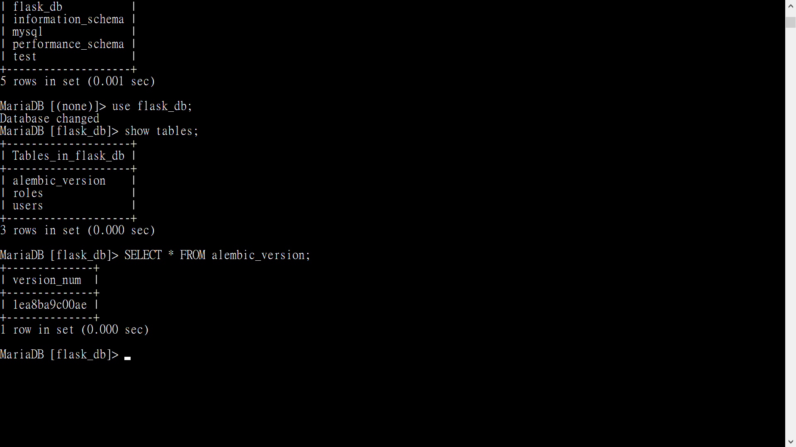

再次執行：

flask db init

flask db migrate -m "initial migration"

flask db upgrade

